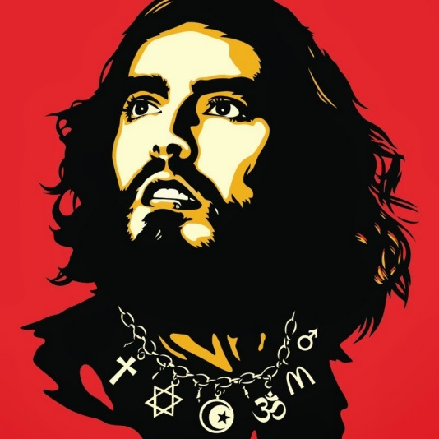-Since 2013, Brand has appeared more frequently as a campaigner for serious issues rather than an entertainer. On 23 October 2013, Brand was interviewed by [Jeremy Paxman](http://en.wikipedia.org/wiki/Jeremy_Paxman) for the BBC's [Newsnight](http://en.wikipedia.org/wiki/Newsnight" \o "Newsnight) and was challenged about his call for "revolution" and whether someone who had never voted could edit a political magazine. In the issue of the [New Statesman](http://en.wikipedia.org/wiki/New_Statesman), published on 24 October 2013, Brand's essay explained his objection to the destruction of earth through greed and exploitation, and called for a change in consciousness to accompany political and economic measures to achieve a more sustainable future. [Nick Cohen](http://en.wikipedia.org/wiki/Nick_Cohen) in The Guardian commented about Brand: "He writes as if he is a precocious prepubescent rather than an adolescent: a child, born after the millennium, who can behave as if we never lived through the 20th century." In June 2014, he took part in the [People's Assembly Against Austerity](http://en.wikipedia.org/wiki/People%27s_Assembly_Against_Austerity), that attracted an estimated 50,000 people marching from the BBC office to [Westminster](http://en.wikipedia.org/wiki/Westminster). Brand addressed the crowd, saying, "The people of this building [the House of Commons] generally speaking do not represent us, they represent their friends in big business. It's time for us to take back our power. Power isn't there, it is here, within us. The revolution that's required isn't a revolution of radical ideas, but the implementation of ideas we already have." Shortly afterward, Brand appeared on Newsnight again, but was interviewed by [Evan Davis](http://en.wikipedia.org/wiki/Evan_Davis) on this occasion. Asked about [9/11 conspiracy theories](http://en.wikipedia.org/wiki/9/11_conspiracy_theories) and whether the attacks were perpetuated by the American government, Brand commented: "we have to remain open-minded to [that] kind of possibility," although this section of the interview ended with Brand insisting that he did not "want to talk about daft conspiracy theories." [Hadley Freeman](http://en.wikipedia.org/wiki/Hadley_Freeman) in The Guardian mocked the opinions he expressed in the interview: "I’m not entirely sure where he thinks he’s going to go with this revolution idea because revolution is not going to happen. "BBC Three commissioned Brand to make a documentary on the global "[War on Drugs](http://en.wikipedia.org/wiki/War_on_Drugs)", which aired on 26 November 2014. The film, titled Russell Brand: End the Drugs War, shows him exploring the illicit drug policies of other countries in [search](http://en.wikipedia.org/wiki/Russell_Brand) of a compassionate approach to people who use illicit drugs. Brand explains in the documentary, "People think compassion is 'wet liberalism'; it's not, it's pragmatic". Brand worked with the Matchlight Ltd production company, director Ross Wilson and executive producer Liz Hartford.